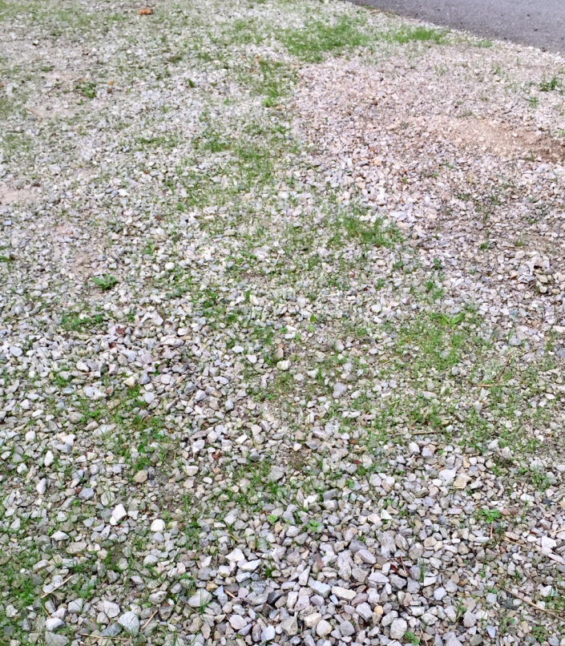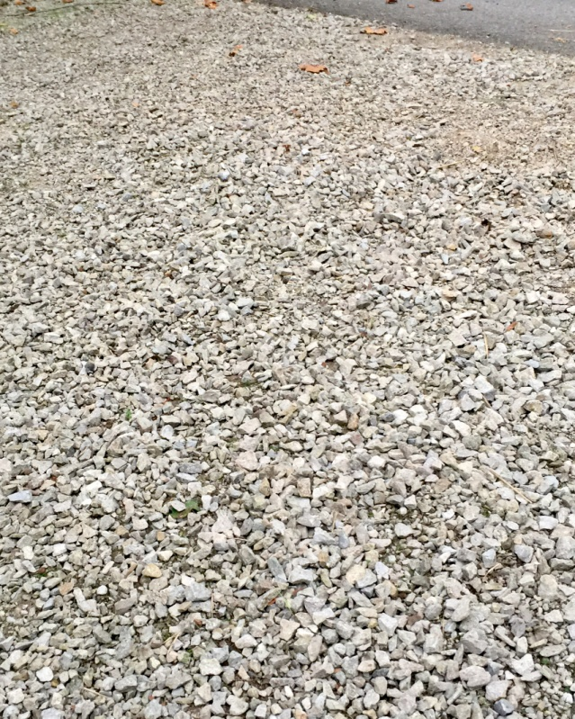
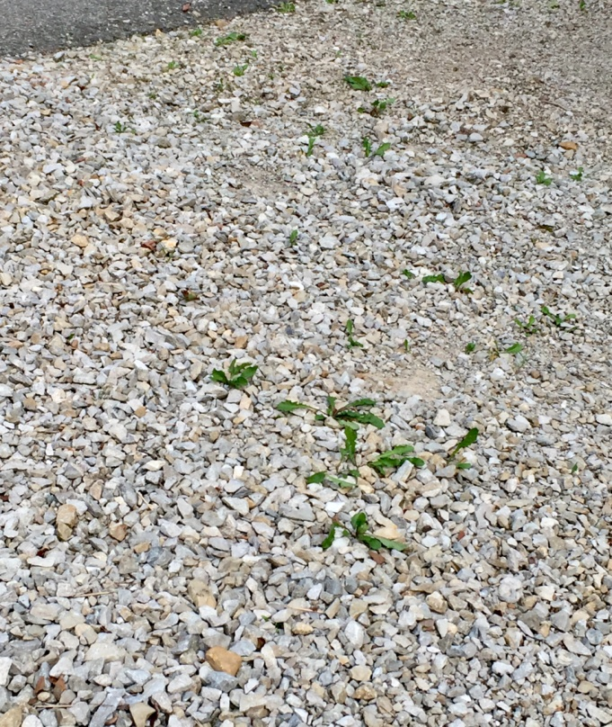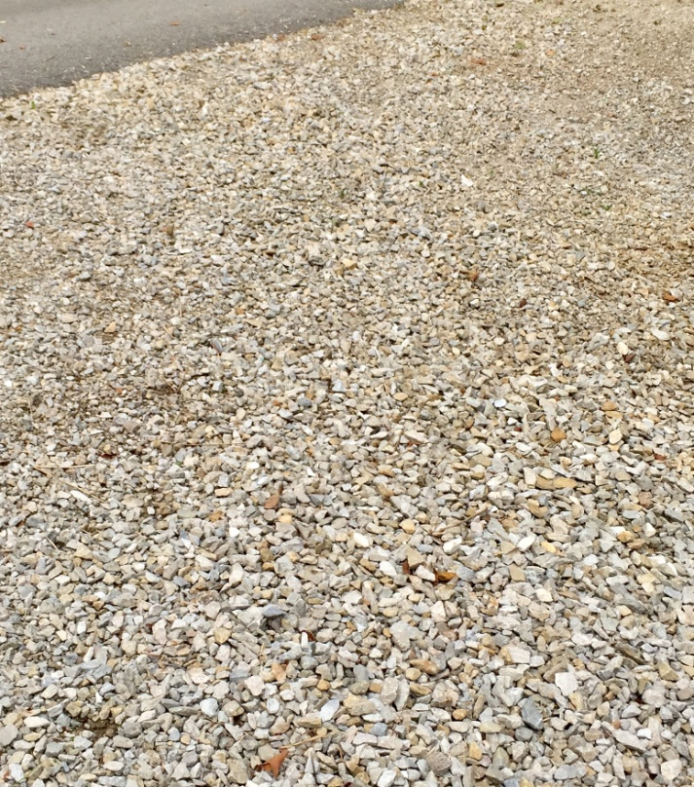
Gravel driveway before weeding Gravel driveway after weeding
Employing the ideas of Henri, any work can be fulfilling and express the Art Spirit, even an activity as mundane as pulling weeds and stray grass out of a gravel driveway (instead of using RoundUp).

